Corona virus is a new illness that has spread across the world. It is also called Covid-19. Some things have changed for people.
We want to find out if some things in your life have changed.
We have some questions we would like to ask.
We will then tell the people in Derbyshire who work to keep you healthy, safe and well what has happened.
We will also tell you what other people have told us. This is called feedback.
Please call 01332 228 790 and leave a message if you would like someone to call you back and help you to fill this form in.

About You.

How old are you?
Are you male or female?
What is your ethnicity?
Please tell us about yourself and use a tick in some of the boxes.

 | I live with an Autistic Spectrum Condition (ASC) | ☐
 | I have a learning disability | ☐
 | I care for someone who has Autistic Spectrum Condition | ☐
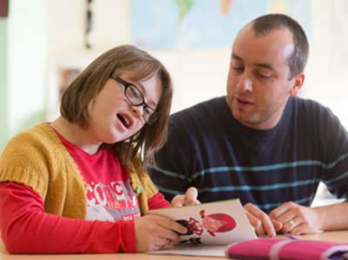 | I care for someone who has a learning disability | ☐

Please tick in the box if you used any of these people or things to support you before Covid-19?

 | I go to a place where people can have a break? This is called respite care or a short break. | ☐
 | I go to building for support during the day – this is sometimes called a day centre | ☐
 | I have a social worker – a worker who is from Adult Services at the Council | ☐
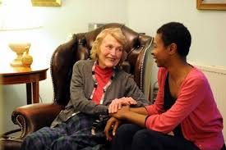 | I have a Befriender or  Companion who may come to my house to talk to me | ☐
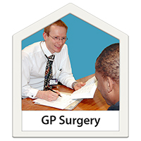 | I go to my Doctors Surgery | ☐
 | I have an Occupational Therapist | ☐
 | I have a Physiotherapist | ☐
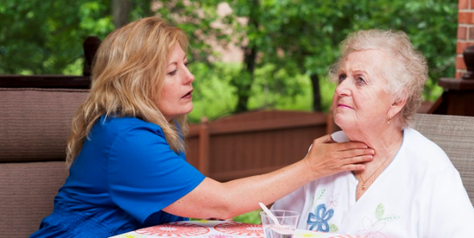 | I have a Speech and Language Therapist | ☐
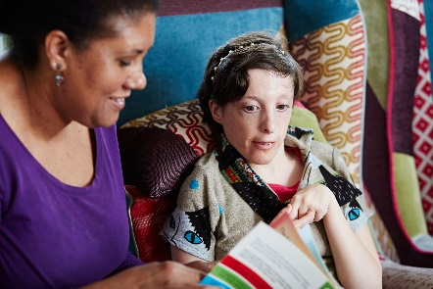  Sit-in Service | I had someone who came to my house to support me so that my carer could go out | ☐
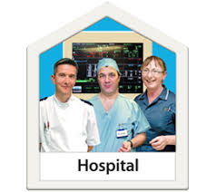 | I go to hospital for treatment | ☐
 | I went to groups like clubs, discos, library groups, church or leisure centre | ☐
 | I see the Mental Health Crisis Team when I need support | ☐
 | I saw a Counsellor or someone I could talk to | ☐
 | I saw the Intensive Support Team | ☐
 | I saw the Community Learning Disability Team | ☐
 | I saw a Psychiatrist. This is someone you could talk to about your feelings | ☐
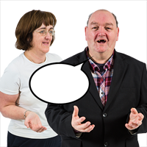 | I have an Advocate who helps me speak up for myself | ☐
 | I have a support worker who helps me with my daily living tasks | ☐
 | I volunteer where I work but do not get paid.  Or I go to work where I do get paid. | ☐
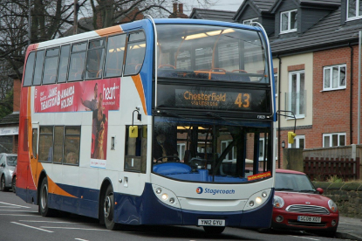 | I use the bus, train or taxi by myself | ☐

Please tick in the box if any of these people or things to support you have changed for you during Covid-19?

 | Stopped | Online | Phone | Video call
Going to my respite care | ☐ | ☐ | ☐ | ☐
 | Stopped | Online | Phone | Video call
Seeing my Social Worker | ☐ | ☐ | ☐ | ☐
Seeing my Befriender or Companion | ☐ | ☐ | ☐ | ☐
Going to my day centre or day service | ☐ | ☐ | ☐ | ☐
 | Stopped | Online | Phone | Video call
Having my Sit-in Service | ☐ | ☐ | ☐ | ☐
Going to the doctor  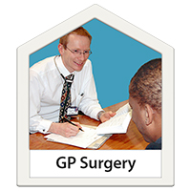 | ☐ | ☐ | ☐ | ☐
Seeing my occupational therapist | ☐ | ☐ | ☐ | ☐
 | Stopped | Online | Phone | Video call
Seeing my Psychiatrist | ☐ | ☐ | ☐ | ☐
Seeing my physiotherapist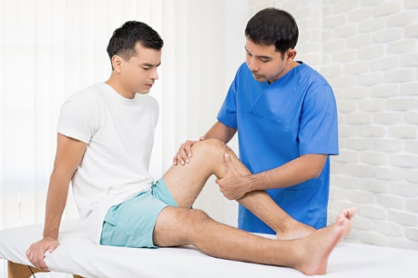 | ☐ | ☐ | ☐ | ☐
Seeing the Mental Health Crisis Team | ☐ | ☐ | ☐ | ☐
 | Stopped | Online | Phone | Video call
Seeing the Intensive Support Team | ☐ | ☐ | ☐ | ☐
Seeing my Speech and Language Therapist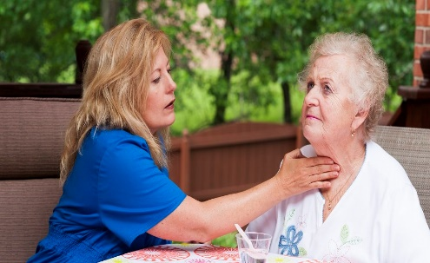 | ☐ | ☐ | ☐ | ☐
Seeing my Advocate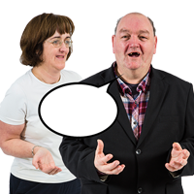 | ☐ | ☐ | ☐ | ☐
 | Stopped | Online | Phone | Video call
Seeing my Support Worker | ☐ | ☐ | ☐ | ☐
Going to hospital for treatment | ☐ | ☐ | ☐ | ☐
 | Stopped | Online | Phone | Video call
Seeing the Community Learning Disability Team | ☐ | ☐ | ☐ | ☐
Going to groups like clubs, discos, library groups, church or leisure centre | ☐ | ☐ | ☐ | ☐
Seeing my counsellor | ☐ | ☐ | ☐ | ☐
 | Stopped | Online | Phone | Video call
Doing volunteering or work | ☐ | ☐ | ☐ | ☐

Please tick the box if any of your support has changed since Covid-19. Is it good, bad or okay?

Good Bad Okay
Going to my respite care place | ☐ | ☐ | ☐
Going to my Day Service or Day Centre | ☐ | ☐ | ☐
Seeing my social worker | ☐ | ☐ | ☐
Seeing my befriender or companion | ☐ | ☐ | ☐
Going to the doctor | ☐ | ☐ | ☐
Seeing my Advocate | ☐ | ☐ | ☐
Seeing my occupational therapist  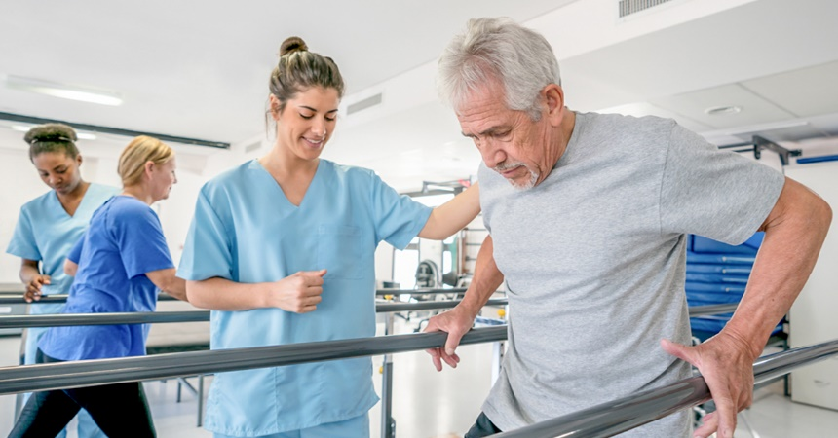 | ☐ | ☐ | ☐
Seeing the Community Learning Disability Team | ☐ | ☐ | ☐
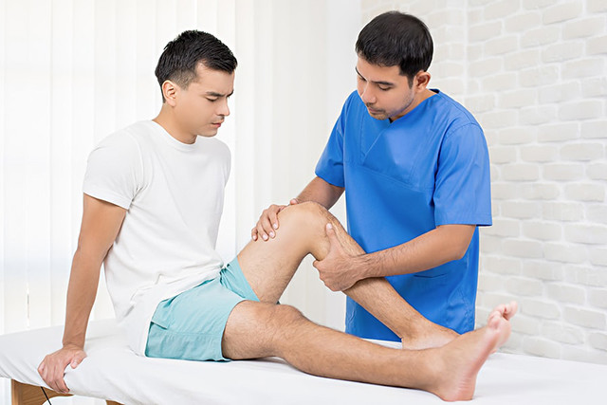  Seeing my physiotherapist | ☐ | ☐ | ☐
Seeing my speech and language therapist  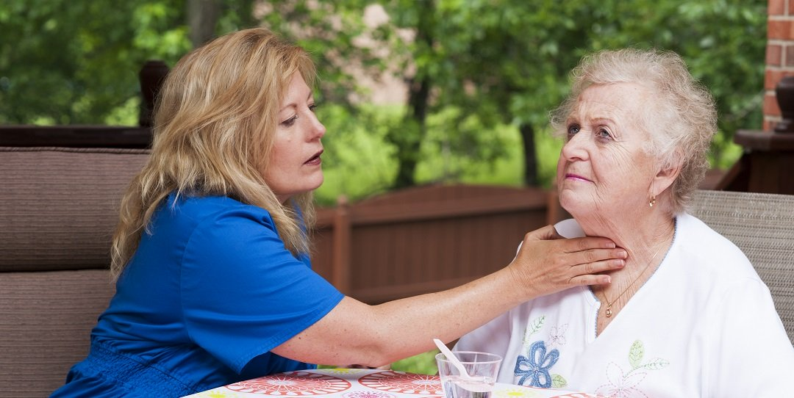 | ☐ | ☐ | ☐
Seeing my psychiatrist | ☐ | ☐ | ☐
Seeing my Counsellor | ☐ | ☐ | ☐
Seeing the Intensive Support Team | ☐ | ☐ | ☐
Having my sit-in service | ☐ | ☐ | ☐
Going to the hospital for treatment | ☐ | ☐ | ☐
Going to groups like clubs, discos, library groups, church or leisure centre | ☐ | ☐ | ☐
Seeing the mental health  crisis team | ☐ | ☐ | ☐
Seeing my support worker | ☐ | ☐ | ☐
Doing volunteering or work | ☐ | ☐ | ☐
Using the bus, train or taxi  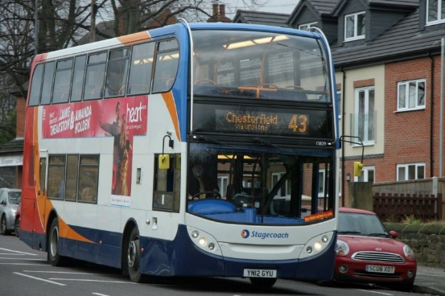 | ☐ | ☐ | ☐
Please tick the box if you have used any new people or things since Covid-19?

 | I have used them | I want to use them again
Mental Health Services. This is support with your Mental Health when it becomes difficult to cope with your thoughts and feelings | ☐ | ☐
I went to a food bank. This is a place where you can get food if you can’t afford to pay for it in the shops | ☐ | ☐
I went to Citizens Advice for some help about difficult problems in my life | ☐ | ☐
I saw my Social Worker | ☐ | ☐
I went to the emergency department at hospital | ☐ | ☐
I spoke to an Autism Specialist Service for some help or support | ☐ | ☐
I spoke to a Learning Disability Specialist Service for some support  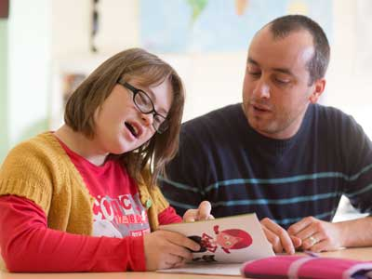 | ☐ | ☐

Please tick the box that tells us about your mental health and feelings before Covid-19?
Please tick

Okay |  | ☐
Good |  | ☐
Bad |  | ☐

Please tick the box that tells us about your mental health and feelings during Covid-19?

Okay |  | ☐
Good |  | ☐
Bad |  | ☐

Please tell us more about the feelings have you felt the most during Covid-19?
Please tick all feelings that you have felt

Happy | ☐
Calm | ☐
Angry | ☐
Confused | ☐
Lonely | ☐
Worried | ☐
Annoyed | ☐
Sad | ☐
Afraid | ☐
Any other feelings?  Please tell us what these feelings were? | ☐

Thank you for answering these questions.

Please call 01332 228 790 and leave a message if you would like someone to call you back and help you.

Please send your completed form back to covid19survey@citizensadvicemidmercia.org.uk, or post it back to:
Citizens Advice Mid Mercia
114 Church Street
Church Gresley
Swadlincote
DE11 9NR

